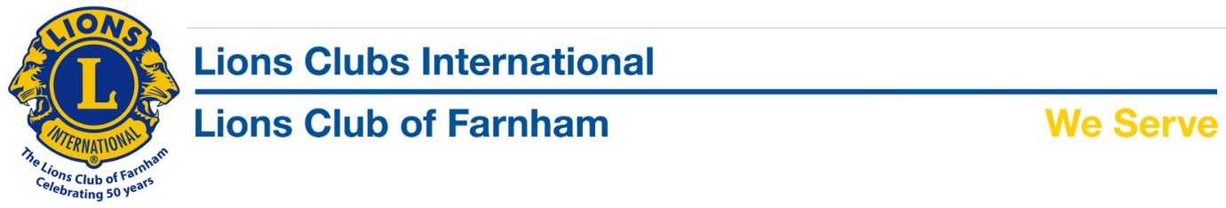
PRESS RELEASE
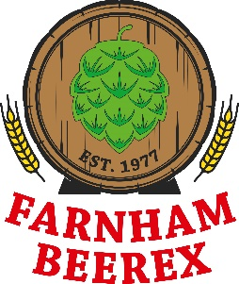
Drinking for Charity
We are delighted to confirm that the proceeds from the 2017 41st ‘Beerex’ amounted a fantastic £42213.76p all of which will be used by the Lions Club of Farnham to support local good causes, whether it be an individual, couple, family or organisation in need of support.
The ‘Farnham Lions’ in association with CAMRA would like to thank all those that ‘drank for charity’ and in doing so raised so much.
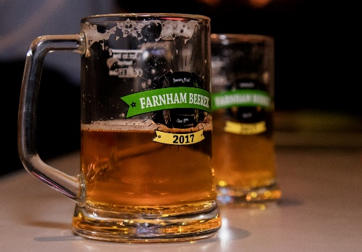
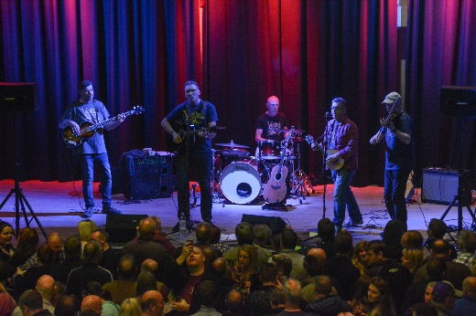
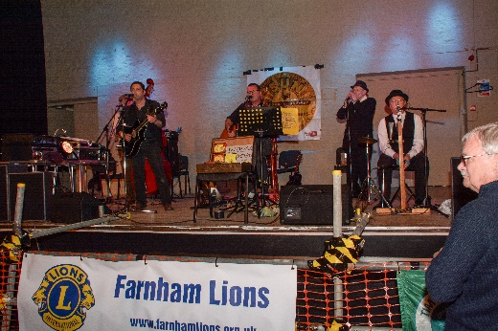
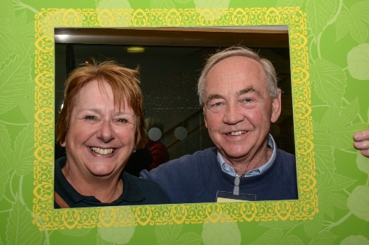
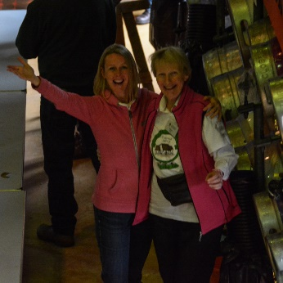
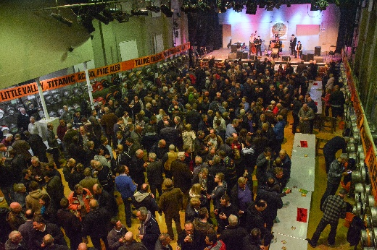
The planning for next year’s event has already begun. The 2018 Beerex which will be on April 12th-14th will not only be the 42nd and longest running Beer Festival to take place at the same venue but will also mark the 40th year of association with Bill Tidy and the 50th year of ‘Farnham Lions’. The Public Ticket sale will be at the Farnham Maltings on Sunday, February 11th between 8am and 10 am.

